Who speaks for
a destination?
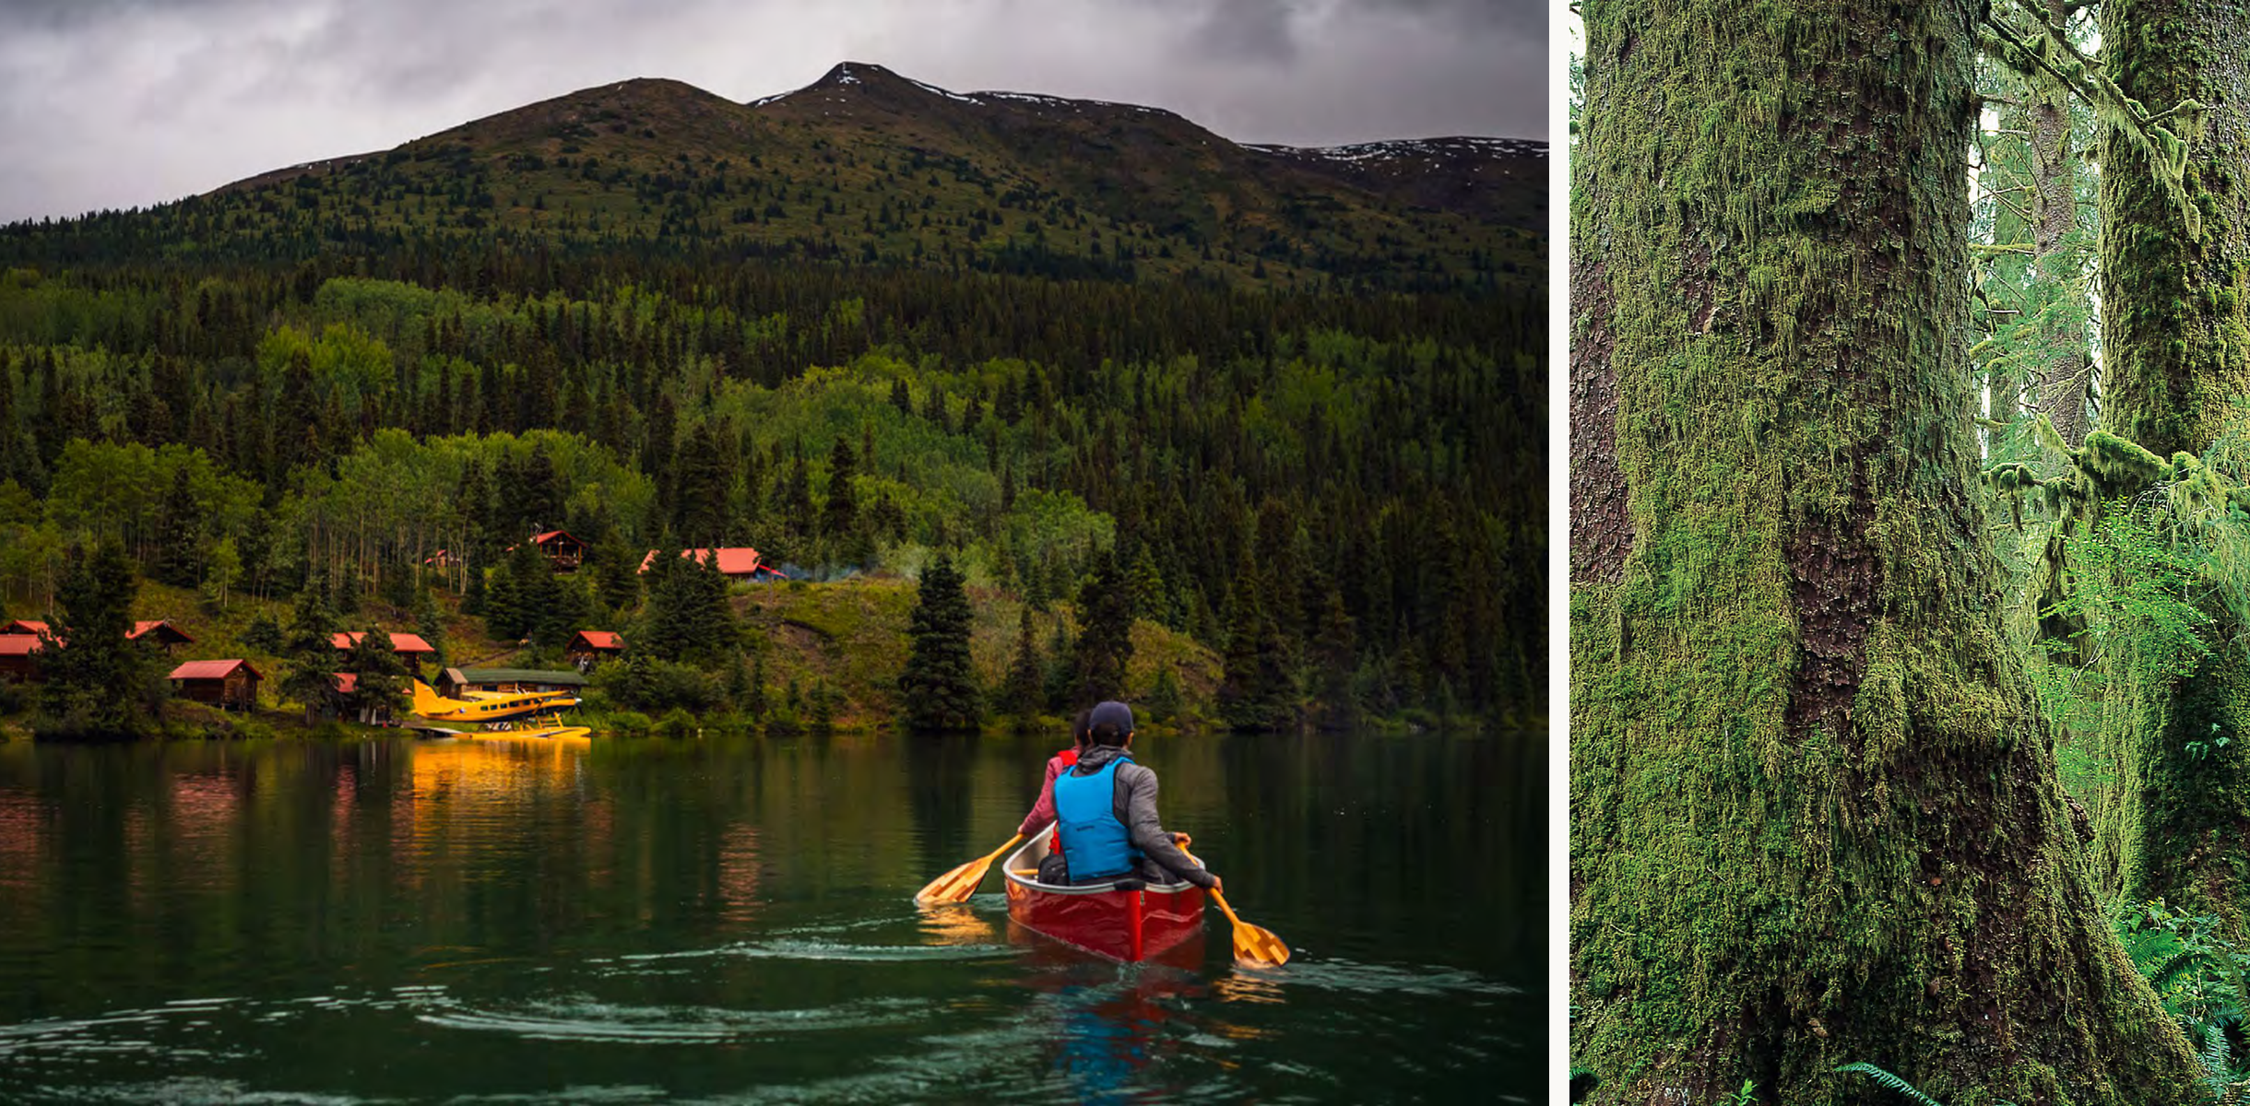
  - A historical study of the language, leadership and stated priorities of British Columbia’s regional tourism organizations.

w

Spatsizi Plateau Wilderness Park and Tahsish-Kwois Park (Destination BC, 2023, p. 19)

Growth. Community. Stewardship.

Written by Status
Earl Healy Proposal (methods for review)

Beneficiaries of tourism
Tourism organizations market landscapes and communities. Their decisions about promotion and development affect residents, businesses and landscapes. For this project I will collect and analyze public documents published by five British Columbia regional destination management organizations (RDMOs) to examine how they present themselves, the destinations they represent and the beneficiaries of their work.

British Columbia’s current Tourism Regions
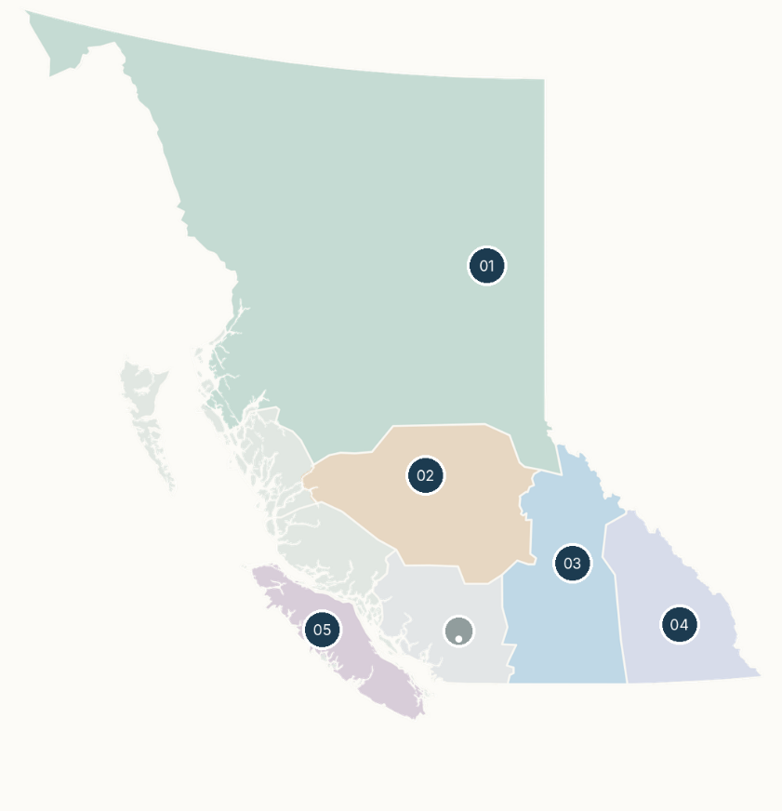
1 Northen BC
Northern BC Tourism Association
2 Cariboo Chilcotin Coast
Cariboo Chilcotin Coast Tourism Association
3 Thompson Okanagan
Thompson Okanagan Tourism Association
4 Kootenay Rockies
Kootenay Rockies Tourism
5 Vancouver Island
Tourism Vancouver Island / 4VI
Figure 1 Boundaries adapted from Destination BC (2023, p. 9). Current geography does not establish historical boundaries.

Corpus and Question
How has RDMO language about economic growth, communities, environmental stewardship and Indigenous participation changed? Do shifts in language coincide with changes in governance and measures of success?
I will link published texts, board members documented affiliations and reported organization performance across three datasets. Systemic Functional Linguistics (SFL), particularly agency and modality, will help examine who is shown acting and how certainty and obligation are expressed. Critical Discourse Analysis (CDA) will help examine whose authority and interests the texts emphasize.

Dataset | Research Subject | Guiding Question
 | Language  Annual reports, executive statements and strategic documents | What priorities dominate the text, and who is represented as acting or benefiting?
 | Governance  Board membership, professional affiliations and election rules | Who holds organizational positions, and how is authority allocated?
 | Performance  Targets, indicators, reported activities and desired outcomes | What do organizations measure and present as successful performance?

Model assisted. Human adjudicated.
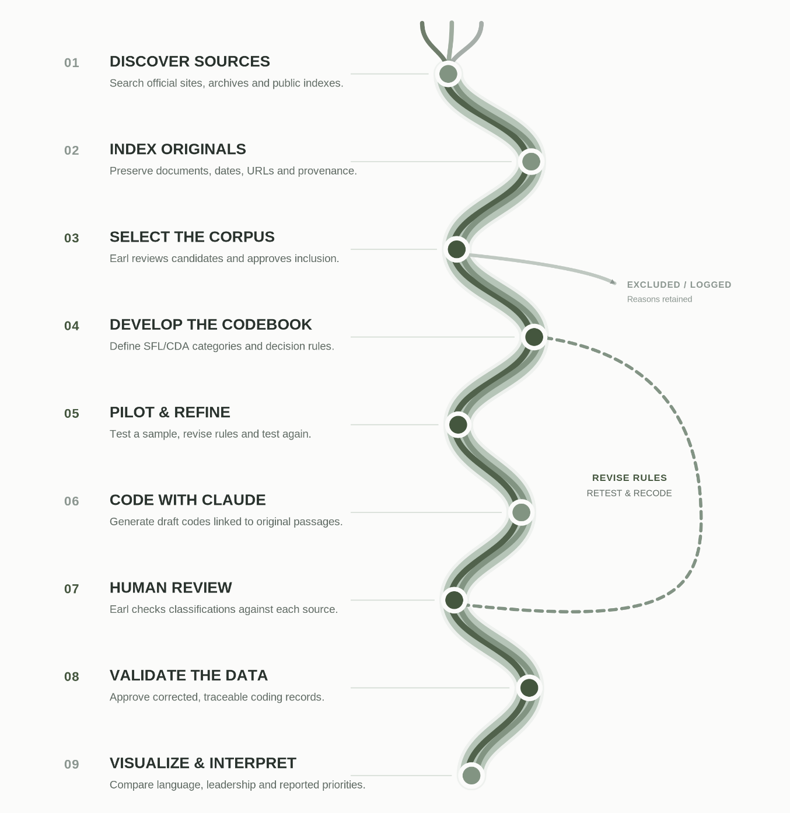
Claude will be used to assist with archival searches, source indexing, coding and data visualization. ChatGPT will be used to review research design, question interpretations and assess evidence. I will select the corpus, establish coding rules, verify AI outputs against original sources and interpret the findings. GitHub will be used to document my methods, prompts, decisions and citations. Third-party documents will remain local rather than being republished. The final product will be an interactive mini-site allowing users to explore the findings and methodology.

References
Destination BC. (2023). BCs tourism Ecosystem. https://www.destinationbc.ca/content/uploads/2023/11/BCs-Tourism-Ecosystem-FINAL.pdf#page=9
Destination BC. (2023). BCs Tourism Ecosystem. https://www.destinationbc.ca/content/uploads/2023/11/BCs-Tourism-Ecosystem-FINAL.pdf?https://www.destinationbc.ca/content/uploads/2023/11/BCs-Tourism-Ecosystem-FINAL.pdf#page=19

